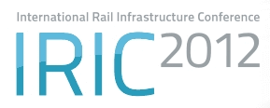
Paper Application
Please complete and return to
 OLTIS Group, Hálkova 171/2, 772 11 Olomouc, Czech Republic  Fax: +420 585 511 276  E-mail: iric@oltisgroup.cz

5 – 6 November 2012

Bratislava, Slovakia

Speaker (first and last name) | Position | English | Czech | Slovak

Organisation

Address

E-mail | Phone

Presentation Title

Brief Abstract

Sub-theme(s) / Preliminary framed sessions (with examples of potential topics)
 | Session 1 |  | Session 2
 | - Efficient development of the  European railway network |  | - Traction energy – a significant source of  costs and savings for the railway transport
 | Session 3 |  | Session 4
 | - Information and communication technology as a tool  to boost efficiency of a railway organisation |  | - Intelligent railways – innovative solutions  for the future of the rail infrastructure
 | Other (please specify):

