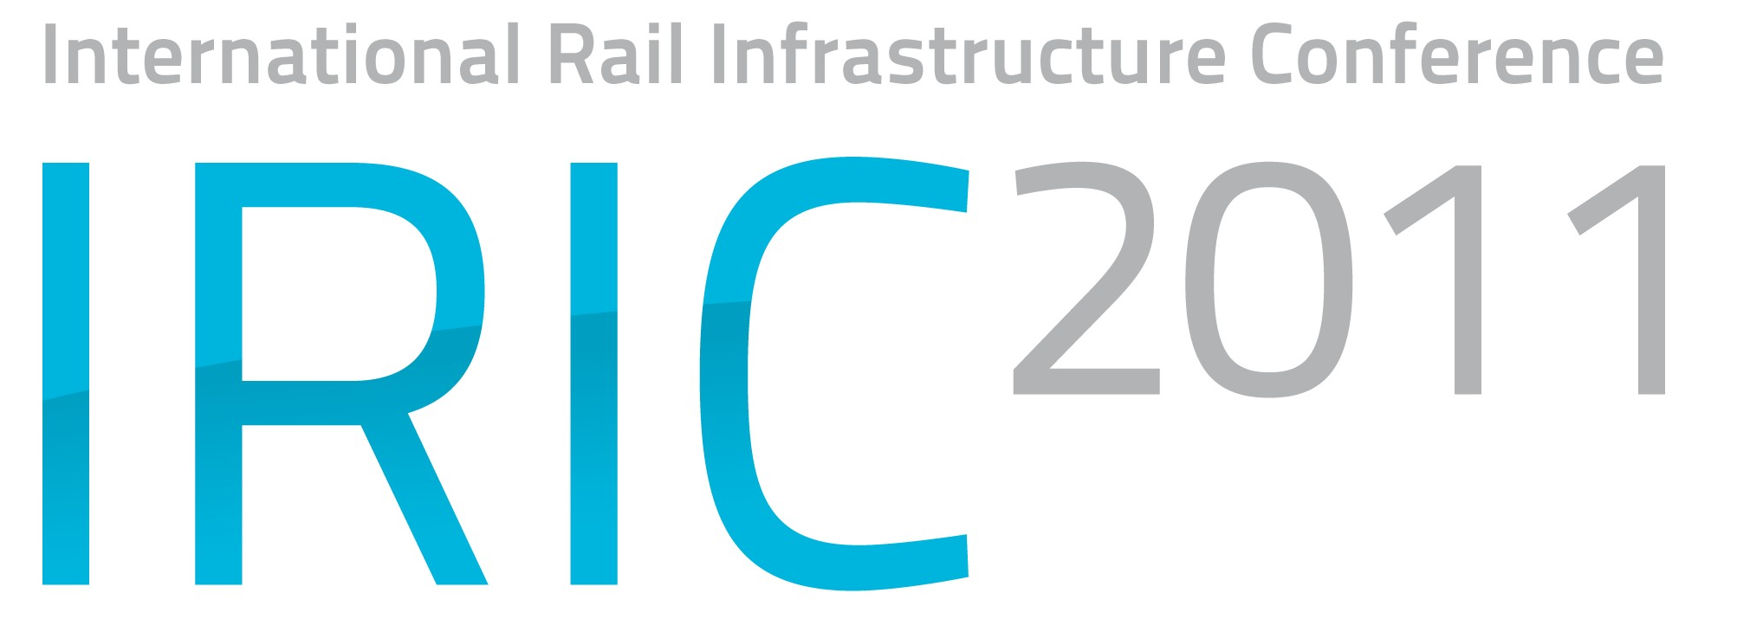
Paper Application
Please complete and return to
 OLTIS Group, Hálkova 171/2, 772 11 Olomouc, Czech Republic  Fax: +420 585 511 276  E-mail: iric@oltisgroup.cz

14 – 16 November

Bratislava, Slovakia

Speaker (first and last name) | Position | English | Czech | Slovak

Organisation

Address

E-mail | Phone

Presentation Title

Brief Abstract

Sub-theme(s) / Preliminary framed sessions (with examples of potential topics)
 | Introductory, General and legislative environment etc. |  | Session 2 - INTEROPERABILITY
 | - Introducing the international and partner organisations  - European Freight Corridors  - Legislative environment  - etc. |  | - ETCS standards  - Technical Specification for Interoperability (TSI)  - Vehicle certification and compatibility with infrastructure  - etc.
 | Session 1 - INFRASTRUCTURE |  | Session 3 - INFORMATION TECHNOLOGY
 | - Engineering, rail, and technical track elements  - Electronic and diagnostic devices  - Interlocking technologies  - Charging the railway access fees  - etc. |  | - Communicating infrastructure  - Data exchange in the international traffic  - Quality of the network traffic  - etc.
 | Other (please nominate):

