





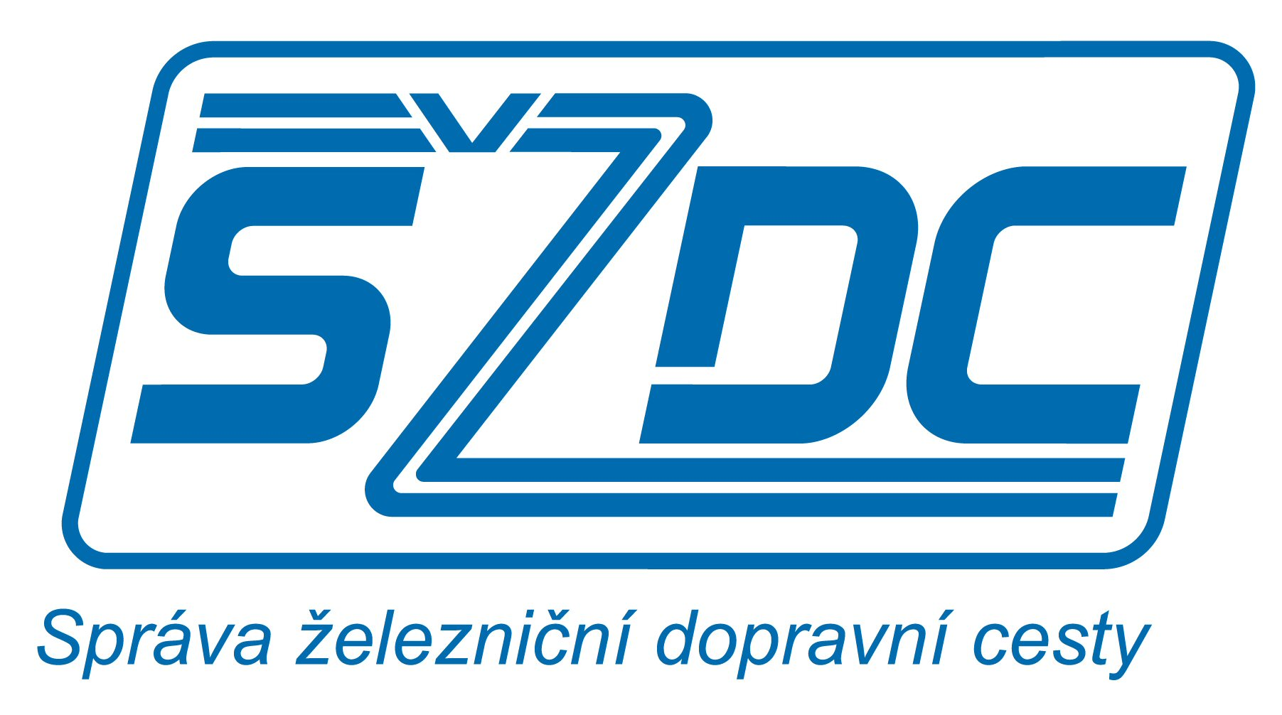

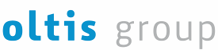

International Rail Infrastructure Conference IRIC 2011  Bratislava  14.–16. 11. 2011
Infrastructure  Interoperability  Information Technology  for European International Rail Transport

IRIC-2011 Sponsorship  www.iric.cz/en

BENEFITS FOR SPONSORS:
- Presenting your company, its market position, offered solutions, and innovative potential
- Excellent opportunity to exchange ideas and experiences, new challenges and chances in the industry
- Advertising, presenting and promoting your company to the industry experts and customers during the conference and after it
- Opportunity to present samples of specific products and practical solutions in the form of an exhibition
- Personal contacts with potential partners and customers

SPONSORSHIP OPTIONS:
Benefits | GRAND SPONSOR | SPONSOR
Your technical presentation  at the conference | yes | yes
No of free admissions for your delegates | 3 | 2
No of your banners in the conference room | 2 | 1
Exhibition stand/space in the exhibitors area | yes | no
Placing your company logo:  - in the conference room  - on the web site | yes | yes  (by 50% smaller)
Free logo provision for the conference room | yes  (max.  2 m²) | no  (max.  1 m²)
Inclusion of your printed materials and promotion items into the conference bags | yes | no
Full list of the participants | yes | no
Price (excl. VAT 20 %) | 3.000 € | 2.000 €
OTHER SPONSORSHIP OPTIONS: (prices excl. VAT 20 %)
1st dinner sponsor | 2.000 €
2nd dinner sponsor | 2.000 €

DISCOUNT 10 % for any order received before 30.09.2011
CONDITIONS:
Please send the order upon completion to the  address: OLTIS Group, Hálkova 171/2, 772 00 Olomouc, CZ
 Fax: +420 585 511 276 or scan it and mail to  E-mail: iric@oltisgroup.cz
- The sponsor bears the production costs of the banner, printed materials and promotion items. This production may be provided by OLTIS Group (against reimbursement).
- All the underlying documents must be sent in the electronic form at latest 20th Oct 2011. The graphical layout must be agreed upon with the organiser.
- In addition to the offered promotion options, the organiser is able to provide other supplementary services; all these promotions have to be specified and agreed upon with the organiser.
- Payments: along with the application, advance payment of 70% is required, for which an advanced invoice is issued. The remaining amount is due before 30th Oct 2011.
- In the case of overlapping requirements, the company with the earlier registration has precedence.

Order
________________________________________________
Company
________________________________________________
Contact person(s)
________________________________________________
Phone Fax
________________________________________________
E-mail Web site
________________________________________________
Address
________________________________________________
Invoicing address
________________________________________________
IČ DIČ
1._____________________ 2._______________________
Delegate names + language (EN/CZ/SK) (may be specified later)
3._____________________ 4._______________________
Delegate names + language (EN/CZ/SK) (may be specified later)
Sponsor category:
GRAND SPONSOR SPONSOR
________________________________________________
Date Signature

